HEART DISEASE

The cautions against carrying heart disease are living a healthy life style and exercise as well controlling risk factors. Some of the precautions are:

1. Adopt a Heart-Healthy Diet:

• Eating More Fruits,Vegetables,Whole Grains: Make high-fiber foods with low-saturated fats a priority.

• Reduce saturated and trans fats: Which means cut back on fried foods, fast food and choose lean proteins fish, poultry, beans, and nuts.

• Watch your salt: excessive sodium can elevate blood pressure.

• Hydrate: Keep your body healthy by drinking plenty of water.

2. Exercise Regularly:

• Reach 150 minutes of moderate aerobic activity or 75 minutes per week of vigorous inactivity.

• Include walking, swimming cycling and strength training to be active in order to maintain the health of your heart.

3. Maintain a Healthy Weight:

- The obese are at higher risk of becoming afflicted with heart disease, hypertension and sugar-box.

• Check your BMI (Body Mass Index) and waist circumference to make sure that you maintain healthy statistics.

4. Manage Stress:

- High blood pressure and cardiovascular disease can develop from long-term stress.

• Regular use of stress-reducing techniques (e.g., meditation, yoga) and deep breathing exercises; sleeping at least 8 hours a day.

5. Limit Alcohol Intake:

- Overconsumption of alcohol has also been found to elevate blood pressure, result in weight gain and contribute to heart disease.

• Moderation: Drink alcohol responsibly (1 drink per day for women, 2 drinks per day for men).

6. Quit Smoking:

- Smoking harms blood vessels and causes them to become stiff, lose their elasticity or clog up. In turn, this leads to high blood pressure as well as a higher risk of heart attacks and strokes.

• If needed, try quitting smoking with therapy (counseling), nicotine replacement or support groups.

7. Control Blood Pressure:

- Checking blood pressure regularly and maintaining it in a normal range (less than 120/80 mmHg).

• If necessary and as ordered, take prescribed medications to help lower blood pressure.

8. Manage Cholesterol Levels:

- Too much cholesterol can cause fatty deposits (plaque) in your blood vessels and this causes narrowing of the arteries, ultimately contributing to heart disease.

• Get onto the right diet, minus those low levels of any TM cholesterol,. (Such as oats and nuts!.) opt for fish oil capsules if advised by your doctor.

9. Regulate blood sugar levels (avoid diabetes):

- Damage to your blood vessels can occur, resulting in heart disease caused by high levels of sugar lurking around in the bloodstream.

• Monitor blood glucose levels and stick to a healthy diet in order to fight off the risk of suffering from diabetes.

10. Get Regular Check-Ups:

- Visit your physician at regular intervals to monitor risk factors for cardiovascular diseases such as cholesterol, blood pressure and glucose levels.

- Early recognition of health problems is crucial in reducing risks that ultimately lead to heart diseases.

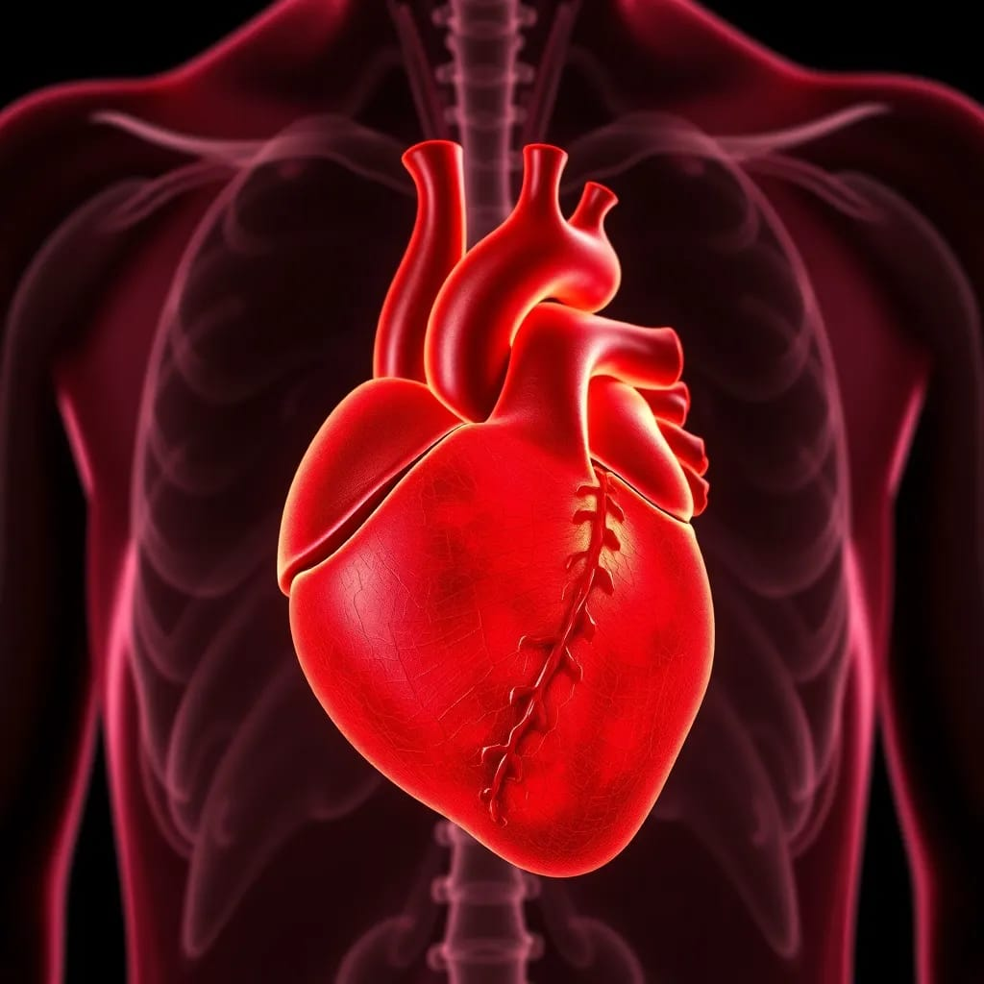

Implementing these precautions, coupled with healthcare guidance to suit specific health requirements protects against the risk of heart disease.